# **Red Team: Summary of Operations**

## **Table of Contents**

* Exposed Services
* Critical Vulnerabilities
* Exploitation

### **Exposed Services**

Nmap scan results for each machine reveal the below services and OS details:

nmap -sV 192.168.1.110/24

# Scan output:

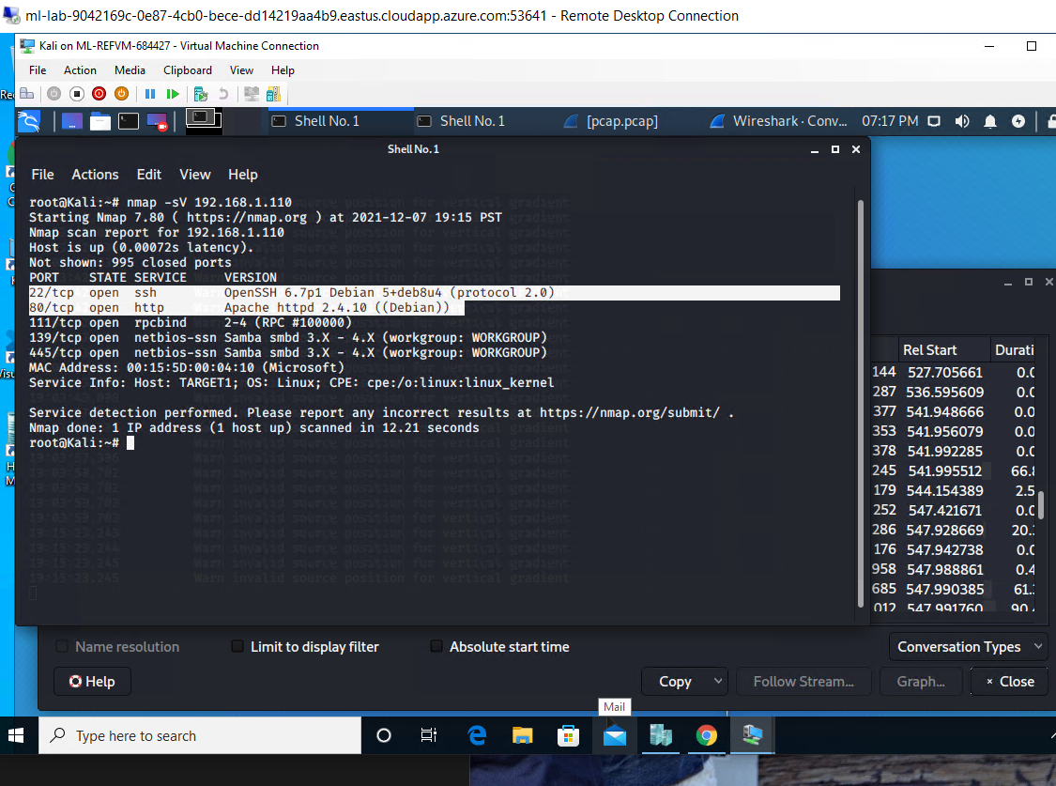

This scan identifies the services below as potential points of entry:

* Target 1
  + Potential points of entry
    - Port 22/SSH
    - Port 80/HTTP

The following vulnerabilities were identified on each target:

* Target 1
  + Vulnerabilities
    - Wordpress version 4.8.7
    - CWE-22 Full Path Disclosure
    - CVE-2021-22515 No Multi-Factor/Two-Factor Authentication

### **Exploitation**

*TODO: Fill out the details below. Include screenshots where possible.*

The Red Team was able to penetrate Target 1 and retrieve the following confidential data:

* Target 1
  + flag1.txt: *b9bbvb33e11b80be759c4e844862482d*
    - **Enumeration scan: to show hidden directories and users**
      * *Found Steven and Michael usernames doing a wpscan -url* [*http://192.168.1.110/wordpress*](http://192.168.1.110/wordpress) *–eunmerate u*
      * 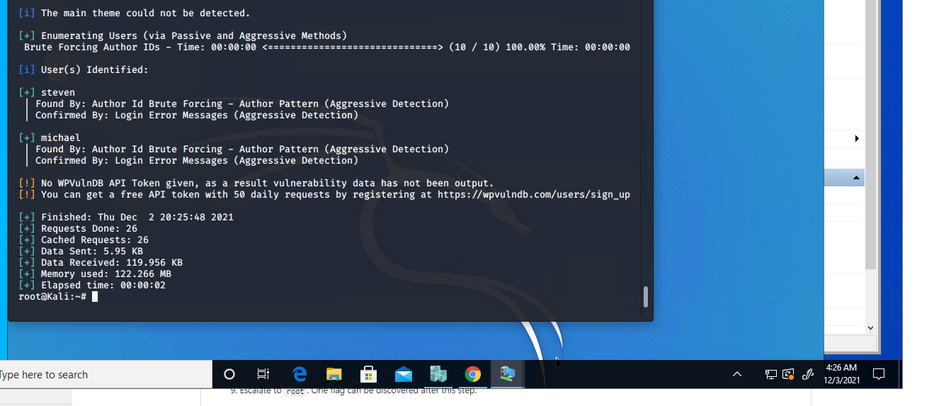
      * *I was able to SSH with michael’s username and guessed his most obvious password.*
      * *I then moved into the /var/www/ directory and did a recursive grep search. Grep -r flag html*
      * 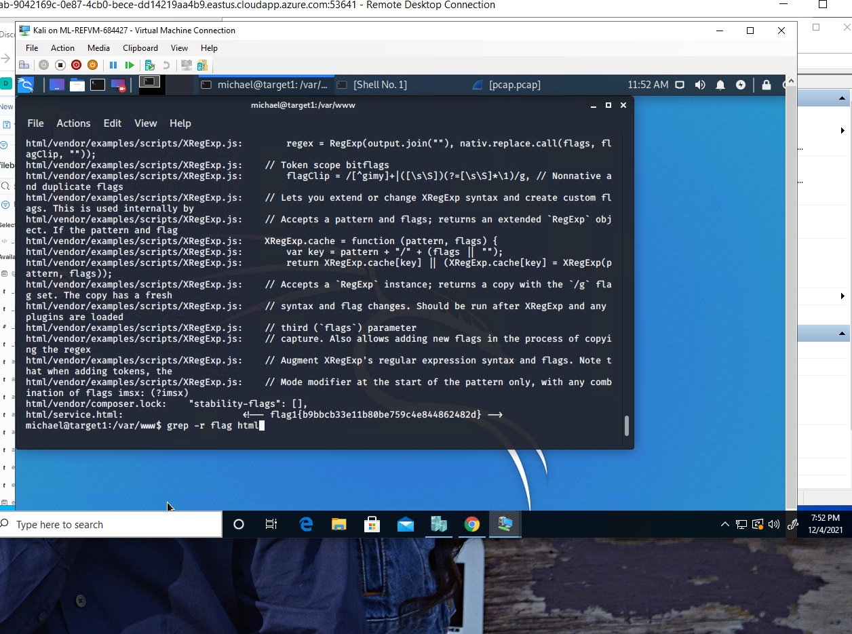
  + flag2.txt: *fc3fd58dcdad9ab23faca6e9a36e581c* 
    - **While exploring michael’s account in the /var/www directory I found flag2.txt. I then cat out the txt file to reveal the hash.**
      * 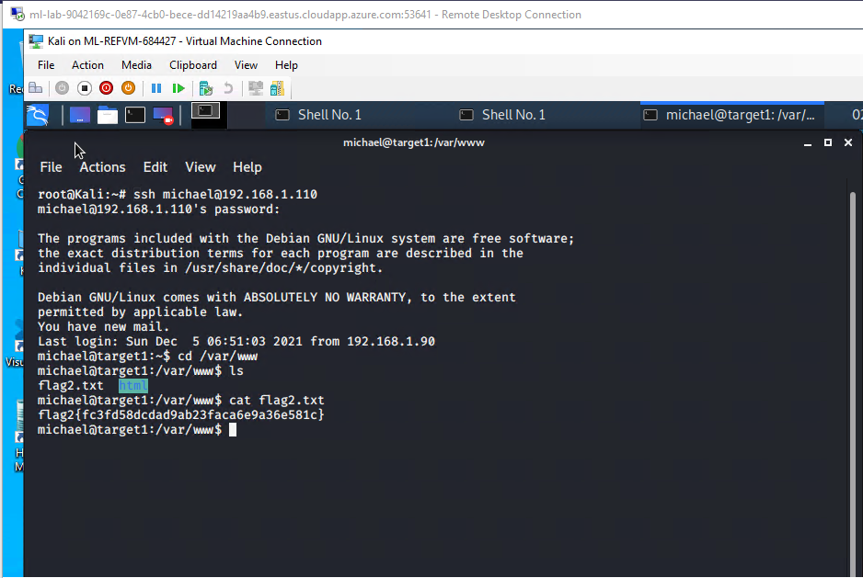
  + flag3: *afc01ab56b50591e7dccf93122770cd2*
    - **I was able to find the username and password for the MySQL database and used it as an exploit when I cat the wp-config.php found in the directory /var/ww/html.**
    - 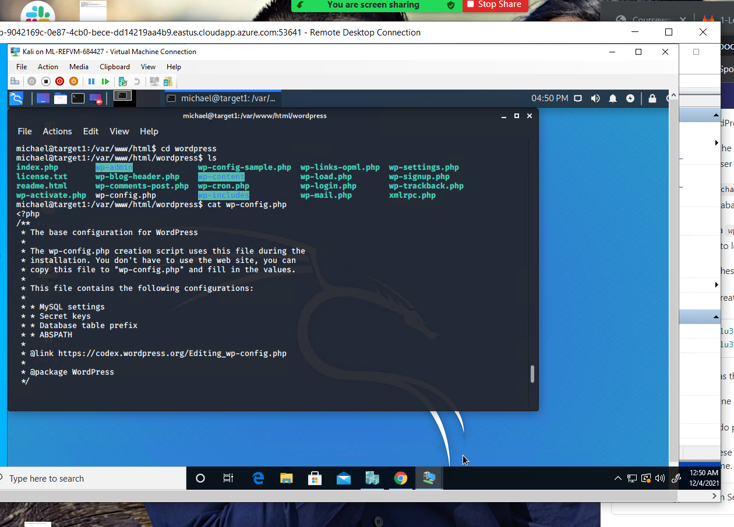
      * 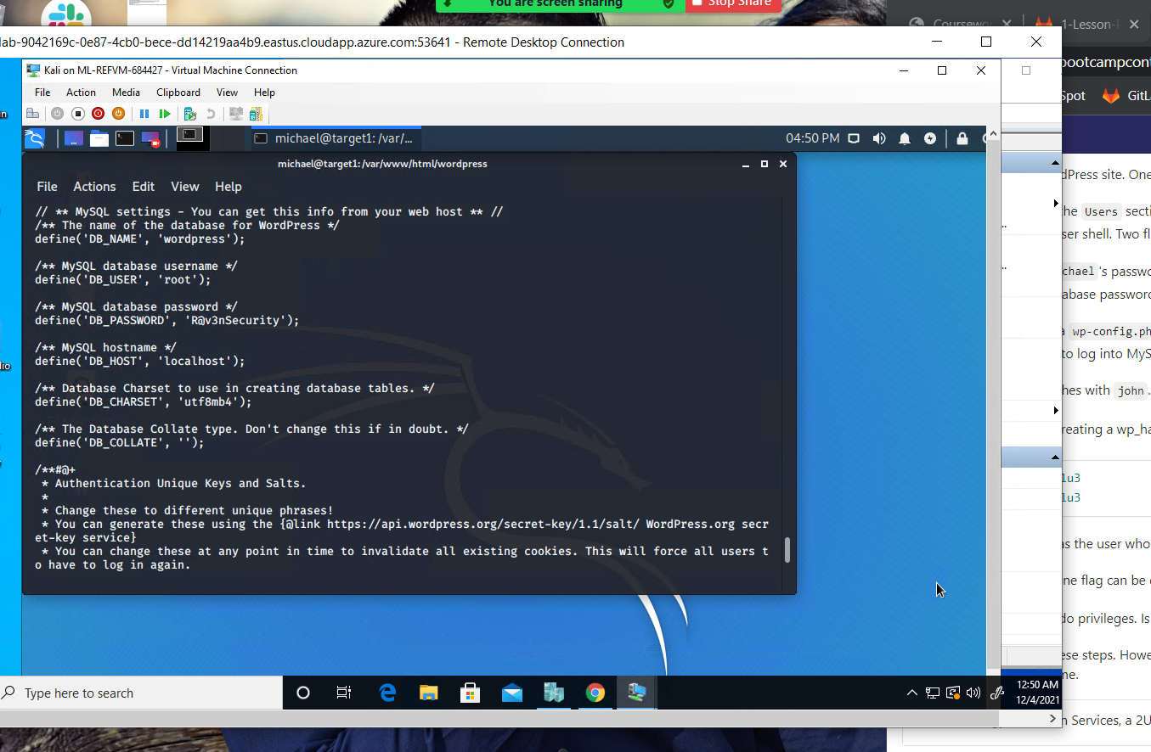
      * mysql -u root -p wordpress
      * 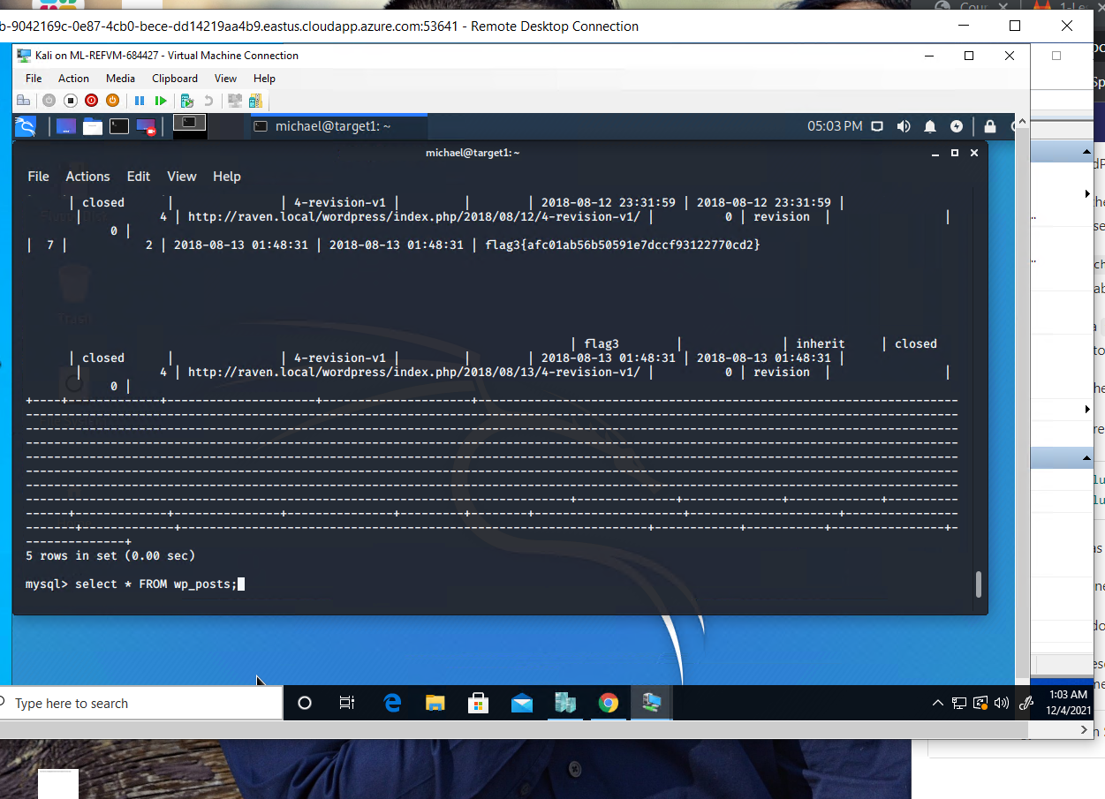
    - flag4: *715dea6c055b9fe3337544932f2941ce*
      * **While in mySQL, I was able to locate the place to find the user information of both steven and michael. And I found their password hashes. I put the hashes in a txt file and used john to crack the hash.**
      * 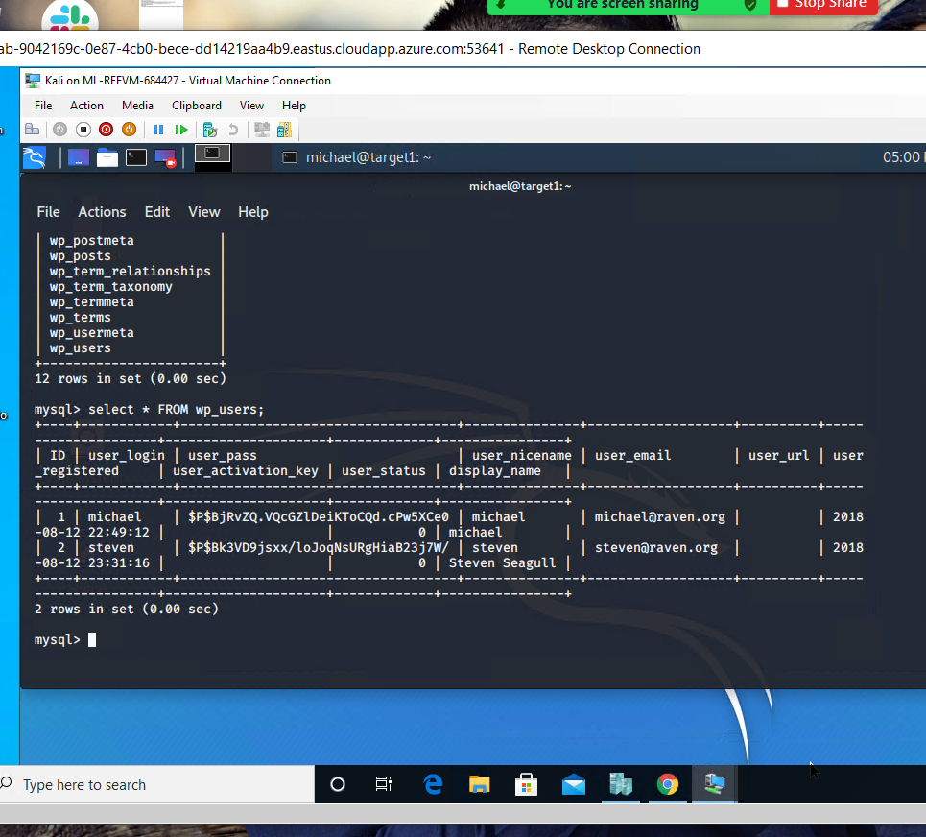
      * 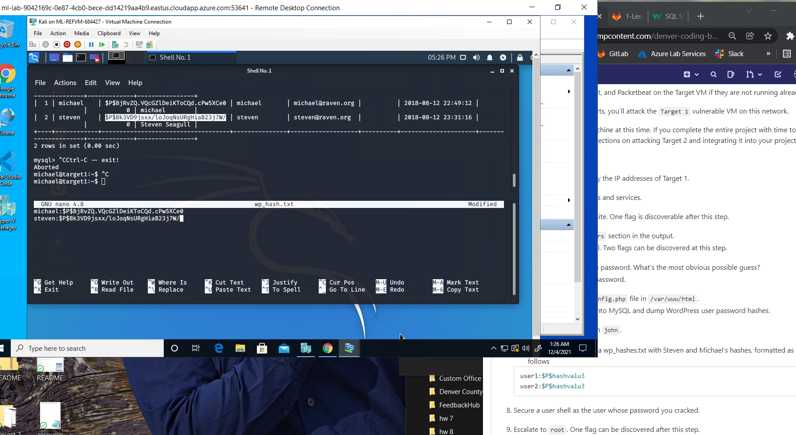
      * 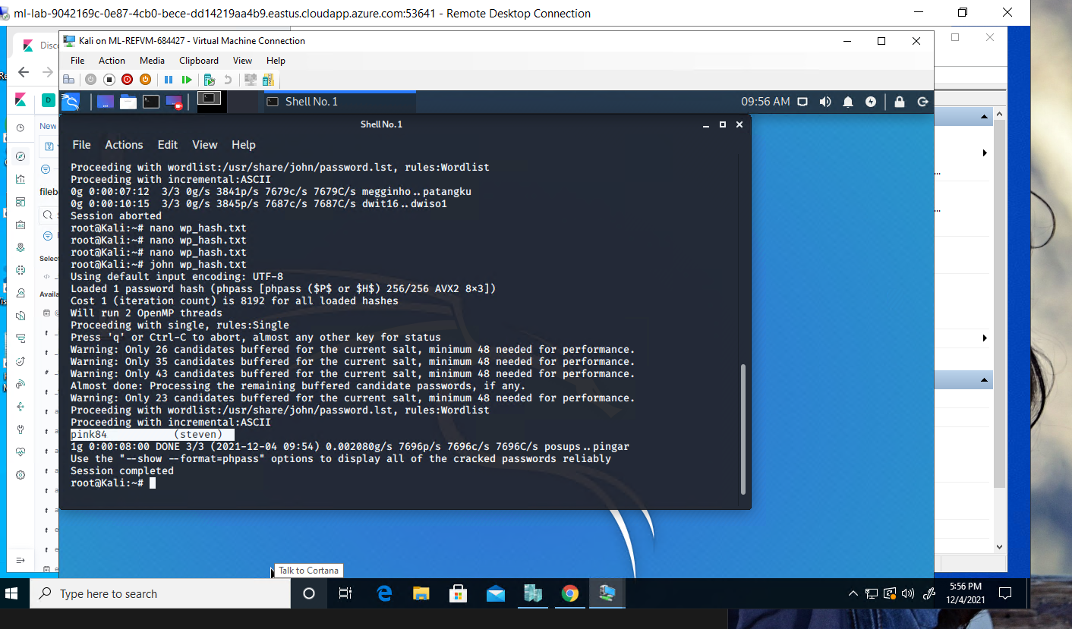
      * **I found a good source to exploit SUID Binaries and was able to locate the 4th flag**
      * 